## 1. Risk Identification

Air pollution is characterized by a contamination of the indoor or outdoor (ambient) environment by any agent that modifies natural characteristics of the atmosphere. Air pollution causes several million deaths each year and is a leading environmental health risk affecting everyone.**Error! Bookmark not defined.** Nearly 4.3 million premature deaths per year are attributable to indoor air pollution and roughly 3.7 million premature deaths are thought to be caused by outdoor air pollution (2012 WHO estimates)..[1] Adverse health impacts result from particles in the air such as dirt, dust, soot, and smoke.[2] These pollutants are released by both human natural and sources, such as through the burning of fossil fuels for electricity and transport, industrial processes, agricultural practices, or forest fires, volcanic eruptions, and wind-blown dust.[3]

**Case in Point:**

Illegal fires started deliberately to clear forest and peatland for the production of paper and palm oil in Indonesia have repeatedly blanketed much of the region in haze. Landscape fires in Southeast Asia are associated with over 100,000 additional deaths (Johnston, 2012)) Singapore has been particularly affected by these events. The country experienced major haze episodes in 1997, 2013, and 2015, where the Pollutant Standards Index crept past 400 during the summer of 2013 and 340 in 2015 (Erik Velasco, 2015) (Jin Zhou, 2015) (AFP/Reuters, 2013) (BBC, 2015). PSI levels greater than 301 are considered “hazardous” and can result in life-threatening health consequences (National Environment Agency, 2016). In 1997 and 2013 outpatient admissions surged because of adverse health outcomes related to the haze (e.g. rhinitis, asthma, and respiratory infections) (Jin Zhou, 2015), and the country distributed over 4 million dust masks to its 5.4 million population (Erik Velasco, 2015). Most recently, in 2015, Singapore closed schools for the first time in 12 years to limit the number of people exposed to the hazardous air conditions (Wille, 2015).

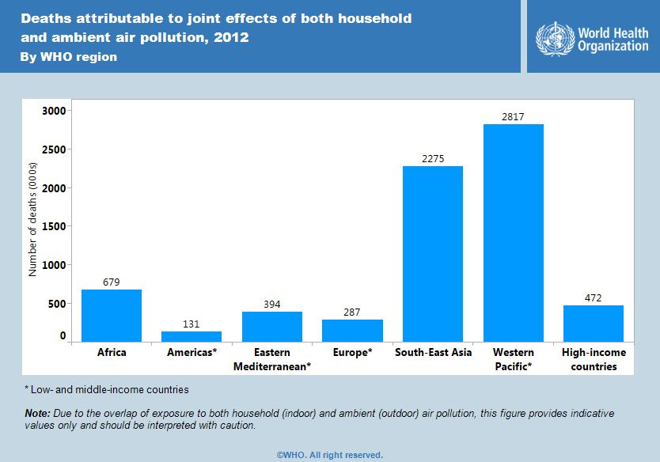

**Health impacts**

Indoor and outdoor air pollution can cause premature deaths and illnesses.**Error! Bookmark not defined.** Both short- and long-term exposure to air pollutants can have impacts on health, primarily manifesting in respiratory and cardiovascular illness. Studies have also indicated that air pollution can result in deposits of toxins in the body, which may lead to birth defects, developmental delays in children, and a suppressed immune system (Kampa et al. 2008). Improving air quality can reduce these burdens of disease.1 Some of the diseases linked with air pollution include:

* Difficulty breathing
* Skin irritation
* acute respiratory disease,
* pneumonia
* chronic obstructive pulmonary diseases (COPD),
* asthma,
* stroke,
* ischaemic heart disease,
* cancer.[4]

**Mechanisms**

Air pollution arises from the release of particles from natural or anthropogenic sources (e.g. forest fires, volcanic eruptions, motorized vehicles, household stoves, power stations etc.) or from chemical reactions in the atmosphere such as the production of ozone. Fine particles with a diameter of 10 micrometers (e.g. PM10 or PM2.5) or less, can be inhaled into the lungs and lead to cardiovascular and respiratory disease and cancers.12 Differing compositions of air pollutants, as well as the time and length of exposure, lead to diverse human health impacts. The main pollutants that significantly affect health are nitrogen dioxide (NO2), particulate matter (PM), ground level ozone (O3), sulfur dioxide (SO2), and carbon monoxide (CO). 2[5]

**Where is poor air quality a health problem?**

Air pollution occurs throughout the world and has wide national and regional disparities. Although the movement of air defies political boundaries, making air quality a trans-boundary issue, outdoor air pollution hotspots are mainly found in large cities.3 Cities in Asia (Karachi, New Delhi, Katmandu, and Beijing), Latin America (Lima and Arequipa), and Africa (Cairo) are especially affected. Nonetheless, substantial health effects also occur in Europe and North America where cities have much cleaner air. Indoor air pollution is especially a problem in countries where people depend on solid fuels (wood, coal, animal dung, crop waste) or kerosene for cooking and heating. In order to estimate the concentration of indoor air pollutants in people’s homes, the proportion of population depending on solid fuels is used as a proxy. This measure indicates that populations in Africa, South and Southeast Asia are especially affected by indoor air pollution

.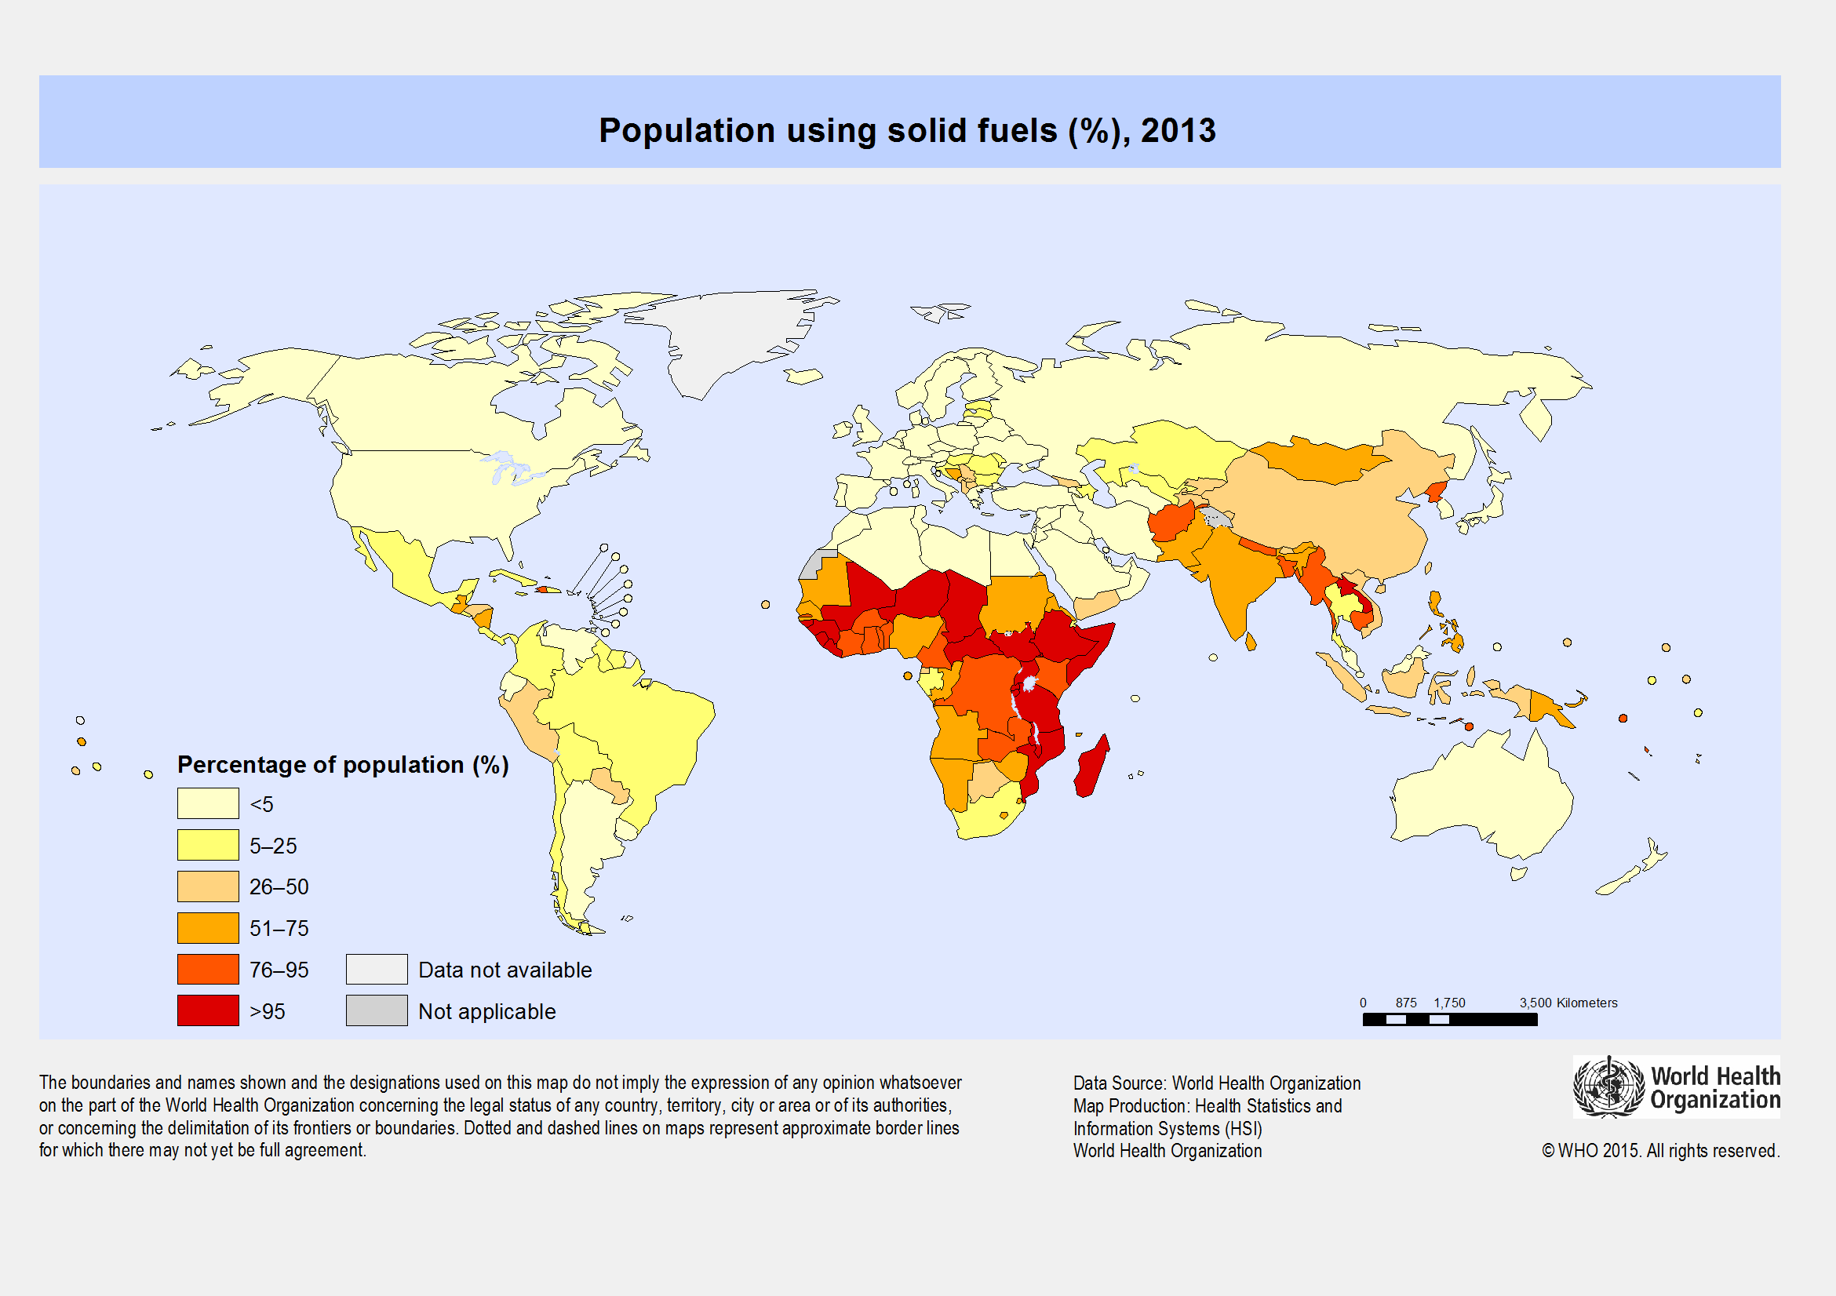

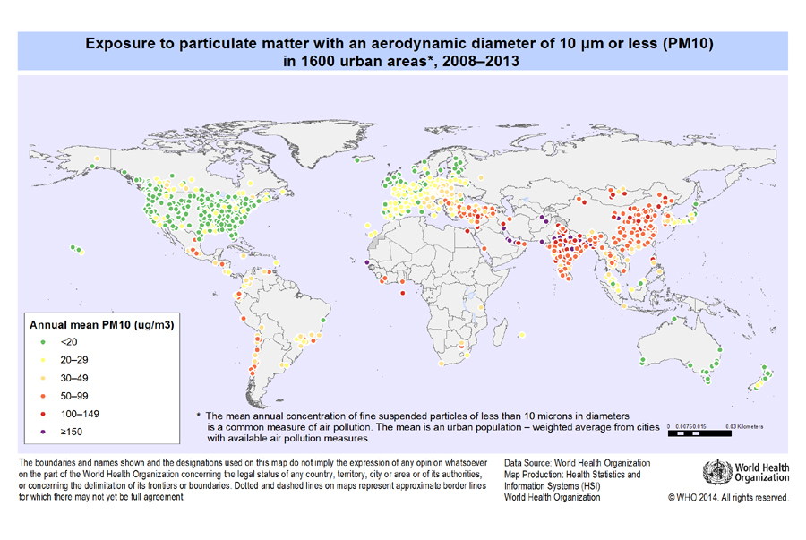

Figure 1. Global map depicting exposure to particulate matter (PM10) in urban areas for 2008-2013.Error! Bookmark not defined.

**Who is at risk?**

As is often the case, developing countries experience the highest burden of air pollution on public health. Low and middle-income countries accounted for 88% of premature deaths in 2012 due to outdoor air pollution, primarily affecting Southeast Asia and the Western Pacific[6]. The burning of solid fuels to heat homes and cook indoors exposes around 3 billion people to indoor air pollution. Women and children in developing countries experience higher exposure to household air pollution as they spend more time indoors, however men experience greater mortality due to underlying disease factors.**Error! Bookmark not defined.**[7] Children are highly vulnerable to adverse health outcomes, as their respiratory organs have not fully developed.[8]Children under five represent over half of the premature deaths due to pneumonia caused by indoor air pollution.1 Additionally, those persons that are already ill, such as people with asthma, allergies, respiratory diseases, compromised immune systems, and other illnesses face the greatest health impacts of air pollution.[9]

**Health problems associated with poor air quality**

* Increases the risks of:**Error! Bookmark not defined.**
  + [Respiratory diseases](http://www.who.int/respiratory/en/)
  + [Cardiovascular diseases](http://www.who.int/cardiovascular_diseases/en/)
  + [Cataract formation](http://www.who.int/topics/cataract/en/)
  + [Cancer](http://www.who.int/cancer/en/)
  + [Stroke](http://www.who.int/topics/cerebrovascular_accident/en/)
  + Premature death in population with heart or lung disease
* Health issues associated with high levels of particle pollution:**Error! Bookmark not defined.**
  + Irritation of eyes, nose, and throat
  + [Asthma](http://www.who.int/topics/asthma/en/)
  + Decreased lung function
  + Coughing, chest tightness, and shortness of breath
  + Irregular heartbeat
  + [Heart attack](http://www.who.int/mediacentre/factsheets/fs317/en/)

**2. Air Quality Monitoring and Forecasting Tools useful for Health Risk Assessment**

|  |  |  |  |  |  |
| --- | --- | --- | --- | --- | --- |
| Risk Monitoring Tools | | Global | Regional | National | Health |
| [WHO Ambient air pollution in Cities Database](http://www.who.int/phe/health_topics/outdoorair/databases/cities/en/) | WHO database for ambient air pollution monitoring from cities and countries around the world depicting annual mean concentration of particulate matter (particles smaller than 10 or 2.5 microns) for 2008 to 2013. Contains data from around 1600 cities and 91 countries. | ● |  |  |  |
| [WHO Global Health Observatory Map Gallery – Environment and Health](http://gamapserver.who.int/mapLibrary/app/searchResults.aspx) | Provides global maps that display information regarding exposure and percentage of population to different air pollution metrics (e.g. population using solid fuels, exposure to particulate matter, etc.). | ● |  |  | ● |
| [Environmental Protection Agency Air Quality System Data Mart](http://www3.epa.gov/airdata/index.html) | Multiple datasets and visualization maps for air quality measurements over the United States. |  |  | ● |  |
| [Tropospheric Emission Monitoring Internet Service (TEMIS)](http://www.temis.nl/index.php) | Air pollution and ozone near-real time data. | ● |  |  |  |
| [Global Ozone Maps](http://exp-studies.tor.ec.gc.ca/e/ozone/Curr_allmap_g.htm) | Current day ozone maps and archives for different spatial scales – global, northern hemisphere, and southern hemisphere. | ● |  |  |  |
| [Satellite Measurements from Polar Orbit (SAMPO)](http://sampo.fmi.fi/index.html) | Real-time satellite data (~15 minutes delayed from satellite passover) of northern hemisphere air pollution data (e.g. ozone and sulfur dioxide). | ● |  |  |  |
| [European Environment Agency Air Pollution Data Centre](http://www.eea.europa.eu/themes/air/dc) | Air pollution data from different sources and measured ambient air pollution across Europe. Products include datasets, maps, interactive maps, air pollution indicators, and graphs. |  | ● |  |  |
| [Local Air Quality and Health Index - Government of Canada](http://www.ec.gc.ca/cas-aqhi/default.asp?lang=En&n=450C1129-1) | Canada’s Air Quality Health Index for cities and provinces around the country. Provides real-time monitoring as well as forecasts for the next 18 hours coupled with health messages. |  |  | ● | ● |
| [Singapore Governments’ National Environment Agency Haze Updates](http://www.haze.gov.sg/haze-updates) | Singapore’s monitoring of haze and health advisories. Provides 24-hour Pollutant Standards Index (PSI) that includes health advisories and recommendations for sub-populations. Includes historical PSI data and hotspot and [satellite images](http://www.haze.gov.sg/hotspot-satellite-images) over Southeast Asia. |  | ● | ● | ● |
| [ASEAN HAZE Action Online – Haze Hotspot Map](http://haze.asean.org/) | Daily hotspot maps derived rom NOAA satellites for the Association of Southeast Asian Nations (ASEAN) Member States. |  | ● |  |  |
| [ASEAN Specialised Meteorological Centre](http://asmc.asean.org/asmc-haze-air-quality/) | Provides air quality data for the past 7 days in cities within the ASEAN Member States. Measurements are based on 24-hour PM10 concentration. |  | ● |  | ● |
| Risk Forecasting Tools | | **Global** | **Regional** | **National** | **Health** |
| [NASA Ozone and Air Quality Data](https://ozoneaq.gsfc.nasa.gov/data/) | NASA data repository containing multiple datasets for ozone and air quality measurements and includes highlights from around the world about pollution hazards and alerts. Temporal scale of data ranges from the 1970s to present day. | ● |  |  | ● |
| [AirNow](http://airnow.gov/) | Provides current maps of air quality for the United States and Canada through the Air Quality Index (AQI), which combines particulate matter and ozone measurements). Maps are translated into language and visuals that enable the public and stakeholders to take action to protect human health. Additionally, the site provides forecasts of AQI for the current day. |  | ● | ● | ● |
| [AirNow International](http://airnow.gov/index.cfm?action=airnow.international) | Based off the US EPA AirNow framework, AirNow International provides links to countries that use their platform to deliver current air quality measurements. | ● |  |  |  |
| [Ozone Forecasts provided by Environment Canada](http://exp-studies.tor.ec.gc.ca/cgi-bin/dailyMaps?language=e&today=20151218&srcf=0&ago=1&source=all&mvdt=1&analysis=de&region=n&region=g) | Forecast maps of total ozone and deviations from normal ozone for multiple spatial scales (global, northern hemisphere, southern hemisphere). | ● |  |  |  |
| [WMO Global Atmospheric Watch](http://www.wmo.int/pages/prog/arep/gaw/gaw_home_en.html) | Contains multiple links to relevant data sites provided by numerous organizations around the world. Additionally, GAW serves as an early warning system with the ability to detect changes in atmospheric concentrations (e.g. acidity and toxicity of rain and atmospheric content of aerosols). | ● |  |  |  |
| [CPTEC – Air Quality Forecasts](http://meioambiente.cptec.inpe.br/) | Provides air quality forecasts for South America. Includes different forecast lead times and monitoring of different pollutants (e.g. Carbon Monoxide, Ozone, and Nitrogen Oxides). |  | ● | ● |  |
| [World Air Quality Forecasts](http://aqicn.org/forecast/world/) | Provides air quality forecasts (8-day forecasts) based on the AQI standard are computed and updated daily. Also includes regional forecasts for Asia, Europe and South America. | ● | ● |  | ● |
| [Copernicus Atmospheric Monitoring Service](http://macc-raq-op.meteo.fr/index.php?category=ensemble) | Air quality forecasts for Europe depicting concentration of atmospheric pollutants. Products come in 3 different formats (hourly ensemble maps, daily mean and maximum, and EPSgrams) with up to a 4-day lead-time. |  | ● |  |  |
| [Air Korea Air Quality Forecast](http://www.airkorea.or.kr/dustForecast) | Provides air pollution and ozone forecasts (only available between 15 April and 15 October) along with ratings and recommendations for public action tips. Air Korea also provides [Air Quality Alerts](http://www.airkorea.or.kr/pmWarning). |  |  | ● | ● |

## 3. Resources for Health Risk Management for Air Quality

|  |  |  |  |  |  |
| --- | --- | --- | --- | --- | --- |
| Risk Management and Communication Tools | | Global | Regional | National | Health |
| Guidance Documents |  |  |  |  |  |
| [WMO Guidelines on Biometeorology and Air Quality Forecasts](https://www.wmo.int/pages/prog/amp/pwsp/pdf/TD-1184.pdf) | Guidance document for NMHSs on methods of incorporating biometeorology and air quality forecasts into their products and services. | ● |  |  | ● |
| [WHO Air Quality Guidelines for particulate matter, ozone, nitrogen dioxide, and sulfur dioxide, Global Update 2005](http://apps.who.int/iris/bitstream/10665/69477/1/WHO_SDE_PHE_OEH_06.02_eng.pdf) | Guidelines for reducing the health impacts of air quality. | ● |  |  | ● |
| [Health Risk Assessment of Air Pollution](http://www.euro.who.int/__data/assets/pdf_file/0006/298482/Health-risk-assessment-air-pollution-General-principles-en.pdf?ua=1) | Provides information on the concept of air pollution health risk assessments and gives an overview of general principles. | ● |  |  | ● |
| [WHO Air Quality and Health Questions and Answer](http://www.who.int/phe/air_quality_q&a.pdf) | Question and answer guide that affords information on background information and provides links to WHO guidance documents and reports on air quality. | ● |  |  | ● |
| [Air Quality in Latin America: An Overview](http://www.cleanairinstitute.org/calidaddelaireamericalatina/cai-report-english.pdf) | Report by the Clean Air Institute on the challenges and recommendations associated with air pollution in Latin America. |  | ● |  | ● |
| [WHO Europe - Health effects of transport-related air pollution](http://www.euro.who.int/__data/assets/pdf_file/0006/74715/E86650.pdf?ua=1) | Report on the health effects caused by transport-related air pollution in the Europe. Guide to help WHO Member States protect human health and the environment, and encourage changes in public behavior and management of transport demands and urban planning. | ● | ● |  | ● |
| [ASEAN Cooperation on Transboundary Haze Pollution](http://environment.asean.org/asean-cooperation-on-transboundary-haze-pollution/) | Document pertaining to the regional haze agreement by the ASEAN Member States. This was the first regional agreement on tackling transboundary haze pollution and serves as a role model for transboundary issues. |  | ● |  |  |
| Web Resources |  |  |  |  |  |
| [WMO Air Quality and Human Health Bulletin](http://www.wmo.int/bulletin/en/content/air-quality-and-human-health-priority-joint-action) | Provides information on air quality and human health along with the role of the health and meteorological communities in developing climate services. | ● |  |  | ● |
| [WMO’s List of Global Research and Monitoring Reports](http://www.wmo.int/pages/prog/arep/gaw/gaw-reports.html) | List of Global Atmospheric Watch research and monitoring products. | ● |  |  |  |
| [Environmental Protection Agency – Air Quality](http://www3.epa.gov/airquality/) | Provides information and resources on air quality policies, standards, pollutants, and more. |  |  | ● |  |
| [WHO Europe](http://www.euro.who.int/en/health-topics/environment-and-health/air-quality) | Air quality information, resources, and publications for Europe. |  |  | ● | ● |
| [WHO - Public health, environmental and social determinants of health (PHE)](http://www.who.int/phe/health_topics/outdoorair/databases/en/) | Contains documents that outline the mortality due to indoor and outdoor air pollution as well as links to the Global Health Observatory. | ● |  |  | ● |
| [CDC – National Environmental Public Health Tracking](http://ephtracking.cdc.gov/showAirHIA.action) | Provides information on the health impacts from outdoor air pollution. Additionally, they provide links to data resources, other government agencies that work on this subject, and supplementary resources. | ● |  | ● | ● |
| Key Relevant Programs and Partners |  |  |  |  |  |
| [World Meteorological Organization](http://www.wmo.int/pages/prog/arep/gaw/gaw_home_en.html) | Global Atmosphere Watch is a program of the WMO that works with its partners to monitor the chemical composition of the atmosphere (natural and anthropogenic), understand the interactions between different aspects of the natural world, and risk reduction of air pollution on health. | ● |  |  | ● |
| [Centers for Disease Control and Prevention](http://www.cdc.gov/air/default.htm) | Communicates and studies the effect air quality has on public health in the United States. |  |  | ● | ● |
| [World Health Organization](http://www.who.int/phe/health_topics/outdoorair/databases/en/) | Studies and communicates the burden of diseases from indoor and outdoor air pollution to improve health. | ● |  |  | ● |
| [National Institutes of Health](http://www.niehs.nih.gov/research/supported/exposure/air_pollution/) | National Institute for Environmental Health Services program studies the environmental impacts on health in order to promote healthier lives. | ● |  |  | ● |
| [ASEAN – Haze Action Online](http://haze.asean.org/) | Regional organization that is tackling transboundary haze issues within ASEAN Member States. |  | ● |  | ● |

# Bibliography

AFP/Reuters. (2013, June 20). *Singapore smog hits critical level, life-threatening for the ill and elderly*. Retrieved February 09, 2016, from http://www.abc.net.au/news/2013-06-21/singapore-smog-hits-record,-life-threatening-level/4772262

AirNow. (2015, October 22). *Particle Pollution (PM)*. Retrieved December 18, 2015, from http://airnow.gov/index.cfm?action=aqibasics.particle

BBC. (2015, September 25). *Singapore anger as haze from Indonesia hits highest level this year*. Retrieved February 09, 2016, from BBC News: http://www.bbc.com/news/world-asia-34355825

Centers for Disease Control and Prevention. (2013, December 17). *Outdoor Air*. Retrieved February 08, 2016, from http://ephtracking.cdc.gov/showAirHIA.action

Erik Velasco, S. R. (2015). Air quality in Singapore during the 2013 smoke-haze episode over the Strait of Malacca: Lessons learned. *Sustainable Cities and Society, 17*, 122-131.

European Environment Agency. (2015, June 09). *Air Pollution*. Retrieved December 18, 2015, from European Environment Agency: http://www.eea.europa.eu/themes/air/intro

Jin Zhou, A. C.-C. (2015, May 07). Particle exposure during the 2013 haze in Singapore: Importance of the built environment. *Building and Environment*.

Johnston, F. e. (2012). Estimated Global Mortality Attributable to Smoke from Landscape Fires. *Environmental Health Perspectives*.

National Aeronautics and Space Administration (NASA) Goddard Space Flight Center. (2013, September 23). *Ozone Hole Watch*. Retrieved December 18, 2015, from http://ozonewatch.gsfc.nasa.gov/facts/SH.html

National Environment Agency. (2016, February 09). *Air Pollution Control: PSI*. Retrieved February 09, 2016, from http://www.nea.gov.sg/anti-pollution-radiation-protection/air-pollution-control/psi/psi

Natural Resources Defense Council. (n.d.). *Air Pollution: Smog, Smoke and Pollen*. Retrieved February 2016, 2016, from Climate Change Threatens Health: http://www.nrdc.org/health/climate/airpollution.asp

Watts et al., N. (2015). Health and climate change: policy responses to protect public health. *The Lancet Commissions, 386*.

Wille, K. (2015, September 27). *Singapore Schools Open After 1st Closure in 12 Years of Haze*. Retrieved February 09, 2016, from Bloomberg Business: http://www.bloomberg.com/news/articles/2015-09-27/singapore-schools-reopen-as-haze-affects-malaysia-s-institutions

World Health Organization (WHO) and World Meteorological Organization (WMO). (2012). *Atlas of Health and Climate.* Geneva: WHO Press.

World Health Organization. (2008). *Air Quality and Health Questions and Answer*. Retrieved February 05, 2016, from http://www.who.int/phe/air_quality_q&a.pdf

World Health Organization. (2011). *Global Health Observatory Map Gallery*. Retrieved December 18, 2015, from http://gamapserver.who.int/mapLibrary/Files/Maps/Global_pm10_countries.png

World Health Organization. (2014, March 25). *7 million premature deaths annually linked to air pollution*. Retrieved February 11, 2016, from http://www.who.int/mediacentre/news/releases/2014/air-pollution/en/

World Health Organization. (2014, March). *Ambient (outdoor) air quality and health*. Retrieved February 08, 2016, from http://www.who.int/mediacentre/factsheets/fs313/en/

World Health Organization. (2014, March). *Burden of disease from Ambient Air Pollution for 2012: Summary of Results.* Retrieved February 11, 2016, from Public health, environmental and social determinants of health (PHE): http://www.who.int/phe/health_topics/outdoorair/databases/AAP_BoD_results_March2014.pdf?ua=1

World Health Organization. (2014, March). *Burden of Disease from Household Air Pollution for 2012: Summary of results.* Retrieved February 11, 2016, from Public health, environmental and social determinants of health (PHE): http://www.who.int/phe/health_topics/outdoorair/databases/HAP_BoD_results_March2014.pdf?ua=1

World Health Organization. (2016). *Public health, environmental and social determinants of health (PHE)*. Retrieved February 5, 2016, from http://www.who.int/phe/health_topics/outdoorair/databases/en/

World Health Organization. (n.d.). *Children's environmental health: Air pollution*. Retrieved February 11, 2016, from http://www.who.int/ceh/risks/cehair/en/

1. (World Health Organization, 2014)
2. (Centers for Disease Control and Prevention, 2013)
3. (European Environment Agency, 2015)
4. (World Health Organization, 2014)
5. (Watts et al., 2015)
6. (World Health Organization, 2014)
7. (World Health Organization, 2014)
8. (World Health Organization)
9. (Natural Resources Defense Council)